**HUMAN RECOGNITION SYSTEM**

**END TERM REPORT**

***By***

**NAME OF THE CANDIDATES:**

**MOHIT THAKUR**

**K18NZ**

**40**

**ANSHU KUMAR SINGH**

**K18NZ**

**41**

**RETINDERDEEP SINGH**

**K18NZ**

**42**



**Department of Intelligent Systems**

**School of Computer Science Engineering**

**Lovely Professional University, Jalandhar**

**APRIL-2020**

**Student Declaration**

**This is to declare that this report has been written by us. No part of the report is copied from other sources. All information included from other sources has been duly acknowledged. We claim that if any part of the report is found to be copied, I/we are shall take full responsibility for it.**

**MOHIT THAKUR**

**Roll number: 40**

**ANSHU KUMAR SINGH**

**Roll number: 41**

**RETINDERDEEP SINGH**

**Roll number: 42**

**Place: Jalandhar**

**Date: 10-04-2020**

**TABLE OF CONTENTS**

**TITLE PAGE NO.**

**1. Background and objectives of project assigned ................ 4**

**1.1 What is Python is used for in business today 5**

**2.0 Uses of Python in businesses 5**

**2.1 For Web development**

**2.2 For Machine Learning**

**2.3 For Data Science**

**2.4 For Game Development**

**2.5 For Entertainment**

**2.6 For NLP**

**2.7 For Blockchain**

**2.8 For Finance**

**BPM Tools 6**

**3.0 Process Modeling 6**

**4.0 Description 7**

**4.1 Highly Flexible Platform 7**

**4.2 Extensive Selection Of Libraries 7**

**4.3 Independent Nature 7**

**4.4 Do More With Less Code 8**

**4.5 Immense Popularity 8**

**BONAFIDE CERTIFICATE**

Certified that this project report **“ARTIFICIALLY CONTROLLING BUSSINESS PROCESSES”** is the bonafide work of **“MOHIT THAKUR, ANSHU KUMAR SINGH, RETINDERDEEP SINGH**”, who carried out the project work under my supervision.

**Signature of the Supervisor**

**Name of supervisor**

**Academic Designation**

**ID of Supervisor**

**Department of Supervisor**

**1.1What is Python is used for in business today?**In recent years, Python has become the language of choice for [**data science**](https://udemy.com/blog/top-3-data-science-skills-trending-in-2018/) and [**artificial** **intelligence**](https://udemy.com/blog/neural-network-and-ai-skills-what-your-business-needs-to-know/)—two technology trends essential for global businesses to stay competitive today. In fact, Python is the fastest-growing programming language today according to [**Stack Overflow’s 2019 Developer Survey**](https://insights.stackoverflow.com/survey/2019). It’s used across a wide variety of applications from web development to task automation to data analysis.

Known for its readability and versatility, Python is used by businesses of all sizes. Startups may optimize a small engineering team’s workflow by utilizing Python’s efficient syntax and leveraging its many package libraries. Large enterprises may turn to Python to process giant datasets using machine learning algorithms. While Python is the current language of choice for many data scientists, web developers, and machine learning experts, is it the right language for you and your team to use? Here, we look at the characteristics of Python that make it so popular, the libraries that expand Python’s functionality, and some of the most common use cases of Python in business today.

**2.0 8 uses of Python in business:**

Python’s popularity is driven by a wide range of companies using it across their products. [**Developer jobs requiring Python skills**](https://insights.dice.com/2018/10/22/python-jobs-booming-2018/) have continued to grow over the last several years, according to data from Dice, a tech recruiting firm. In fact, [**Glassdoor named Data Scientist**](https://www.glassdoor.com/about-us/bestjobs2019/) the best job in America for 2019, a role where Python knowledge is now ubiquitous. Python isn’t just beloved by one type of product or industry. Its flexibility and simplicity have inspired use cases across many [**common services**](https://hackernoon.com/top-seven-apps-built-with-python-2cd8dfd3c00a) including:

* **Python for web development**: Instagram has one billion users around the globe and uses [**Python to efficiently scale its infrastructure**](https://instagram-engineering.com/web-service-efficiency-at-instagram-with-python-4976d078e366) across such a large user base.
* **Python for machine learning**: To power rides across the world, Uber’s various [**engineering teams use Python**](https://eng.uber.com/tech-stack-part-one/) as a primary language and also leverage Python-based machine learning and data science frameworks to build algorithms that better connect drivers to passengers.
* **Python for data science**: Spotify has redefined music streaming with its Discover playlists and smart Radio channels thanks to [**data insights built on Python**](https://labs.spotify.com/2013/03/20/how-we-use-python-at-spotify/).
* **Python for game development**: Video games like The Sims 4 use Python to allow players to [**create in-game modifications**](https://kotaku.com/the-7-most-essential-sims-4-gameplay-mods-1831681576) such as changes to the background or helping your characters find true happiness.
* **Python for entertainment**: Industrial Light and Magic, the movie special effects studio founded by George Lucas, uses [**Python in its proprietary lighting software**](https://realpython.com/world-class-companies-using-python/)**.**
* **Python for natural language processing**: [**Google Home assistant actions**](https://developers.google.com/assistant/sdk/guides/service/python/) like “OK Google, turn the lights on” are powered through natural language processing technology running on Python.
* **Python for blockchain**: Thanks to libraries like Pyethereum, Python can be used to build blockchain-based [**secure, smart contracts on Ethereum**](https://hackernoon.com/ethereum-smart-contracts-in-python-a-comprehensive-ish-guide-771b03990988).
* **Python for finance**: Investment banks like Citigroup and JP Morgan Chase [**train analysts in Python**](https://stxnext.com/blog/2018/09/13/why-python-should-be-technology-choice-your-fintech/) for use in risk assessments and algorithmic trading models.

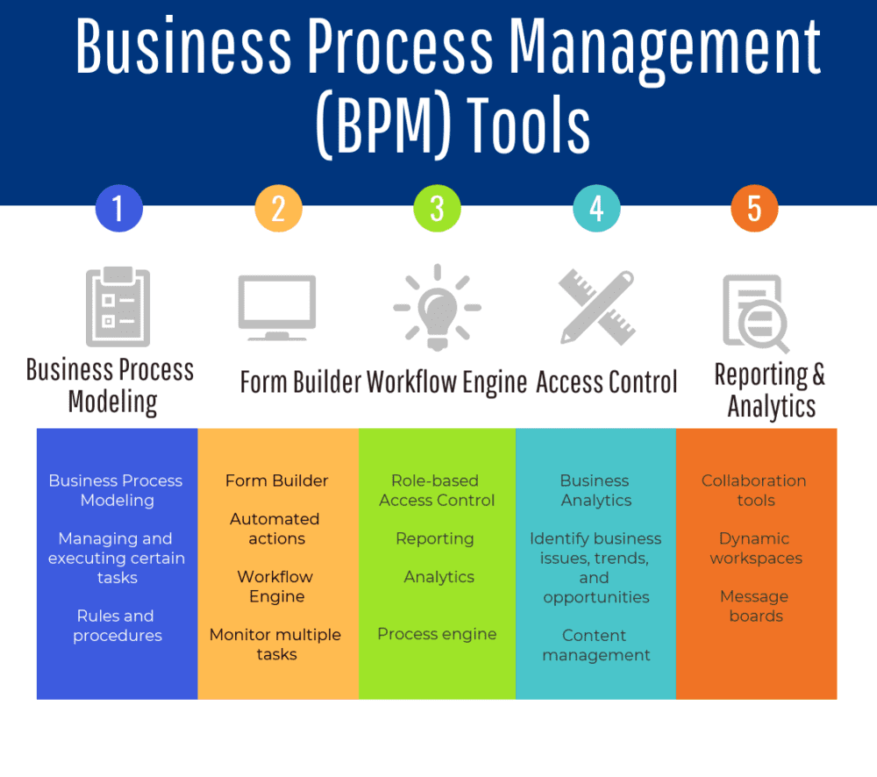

2.0 **The three most important processes known to businesses are:**

1. Management Process (Involves planning and execution of the company's future goals)
2. Operational Process (Involves the day to day core business activities)
3. Supporting Process (Involves supporting processes like tech support, Internships)

### 3. ****Process Modeling:****

Business process modeling is the graphical and analytical representation of a company’s business processes. It helps businesses understand and visually document the  'as-is' processes in a company. It analyzes what processes are already present and provides an insight to add new ones. It helps in achieving a competitive advantage, providing regulatory compliance, and ensuring that the existing processes are formalized. Business Process Modeling is the sum total of:

1. Process mapping
2. Process discovery
3. Process simulation
4. Process analysis
5. Process re-engineering
6. Process improvement

**4.0 AI & ML with Python could it become your ticket to business success:**

Python is built with a principal focus on beautiful design and impressive look. Python is a portable and highly scalable platform. Let’s have a look at what makes Python an ideal alternative for AI and ML.

**4.1 Highly Flexible Platform**

Python is suitable for every purpose language, and it has made easy with the right set of tools and libraries to link data structures for back-end web development, data analytics, web development, and artificial intelligence. Python has a perfect back-end that provides a power produce code in the IDE itself.

**4.2 Extensive Selection Of Libraries**

Libraries are referred to be the collection of pre-written codes and functions, which eliminates the need to rewrite lines of code when it comes to performing complicated tasks. One of the main reasons why Python is a preferred language for AI and ML-based projects.

Most commonly used Python libraries in AI and ML are,

* Pandas
* NumPy
* TensorFlow
* SciPy
* Scikit-learn
* Keras
* Matplotlib
* Natural Language Toolkit (NLTK)
* Scikit-image
* PyBrain
* StatsModels

**4.3 Independent Nature**

The entire process of building solutions functions seamlessly on multiple platforms. Developers can tweak the code and make the application ready to run on different operating systems. It ultimately saves a lot of valuable time that developers can spend on testing apps on various platforms.

**4.4 Do More With Less Code**

In Python, software developers can implement the same logic with less code in the comparison of other programming languages. Python streamlines the whole process of writing and executing code so developers can use an interpreted approach to validate the code while producing it.

**4.5 Immense Popularity**

Python has a simple and short learning curve. Considering the popularity, the Python developers can be easily found in the comparison of other languages. The growing community of Python ensures that with every single update they make the platform even better.

**Epilogue :**We can’t deny the fact that AI and ML have a profound effect in this digital world we live in, as new and improved solutions are coming day after day. Almost all enterprises have realized that there is no better time than now to invest in AI and ML. With the clean and convenient coding format, an amazing set of libraries, outstanding flexibility, fast retyping, and huge community support, Python makes the AI and ML-based development projects a lot easier, in a short amount of time as well as budget-friendly.

**5. 0 Code and their outputes:**

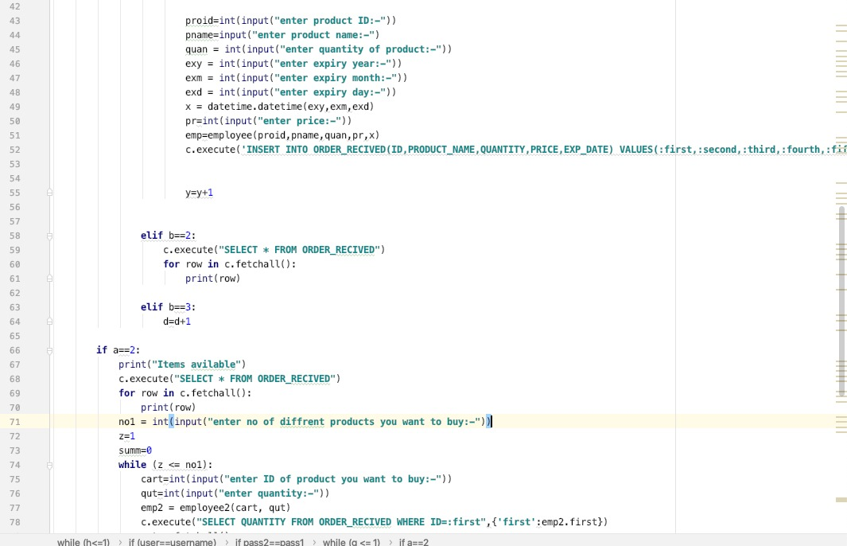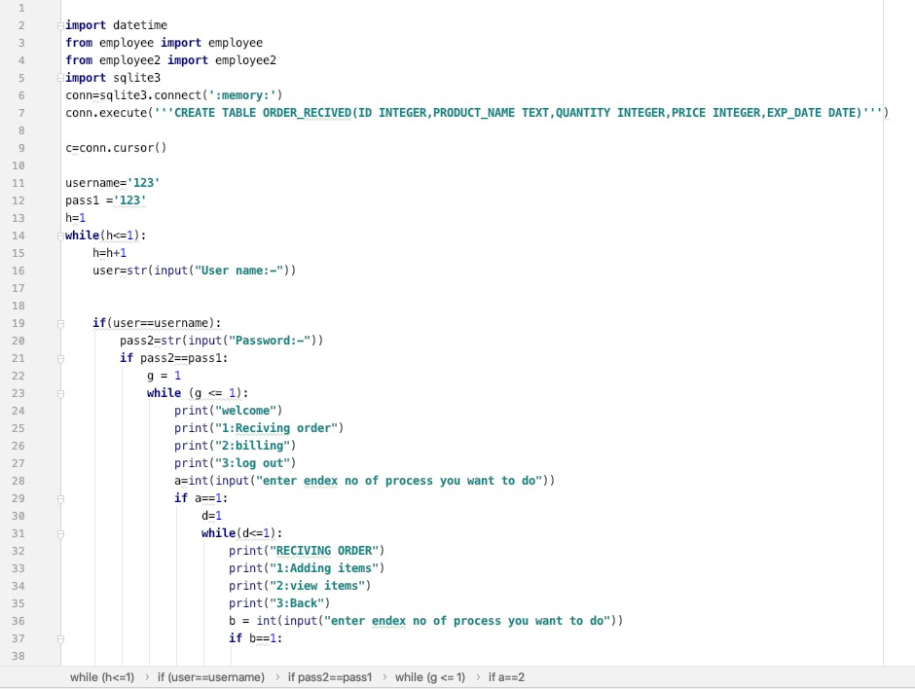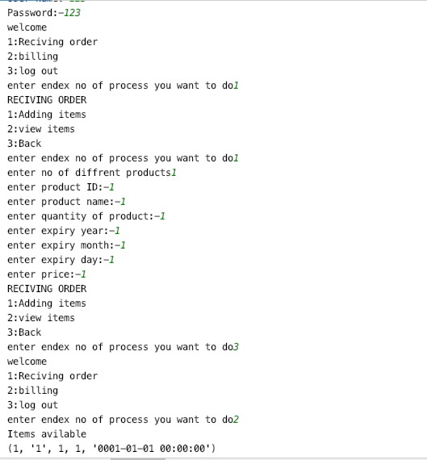

**6.Github Link:** <https://github.com/anshu1516/AI-in-Business>